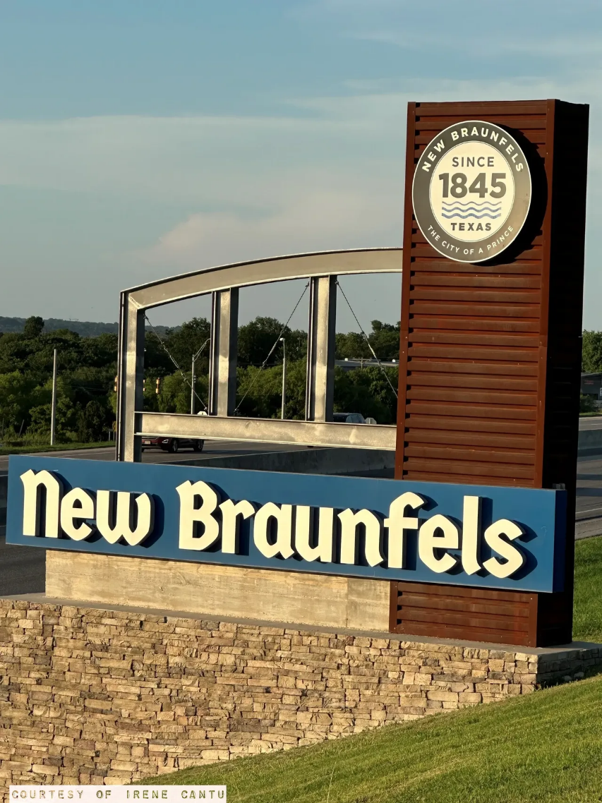

AGENDA

- CALL TO ORDER

- ROLL CALL

- CITIZENS’ COMMUNICATION

This time is for citizens to address the Board on issues and items of concern. Pursuant to the Texas Open Meetings Act, there will be no Board discussion or action on items not on the agenda. Each citizen will be given five (5) minutes to speak.

- INDIVIDUAL ITEMS FOR CONSIDERATION

- Consideration and possible action regarding a resolution to elect officers for the NBHA Public Facility Corporation Board of Directors.

- Consideration and possible action regarding authorizing the park at dogwood apartments transaction, including the execution of all documentation necessary to carry out the transaction; authorizing the formation of nbha dogwood landowner, llc and the purchase of the land for the transaction and the lease of such land for the transaction; and authorizing the acquisition of membership interest in nbha dogwood gp, llc, and its admission as the general partner of comal partners, l.p.; and authorizing the financing for such transaction; and authorizing nbha public facility corporation to serve as the general contractor; and other matters in connection therewith.

- ADJOURNMENT.

CERTIFICATION
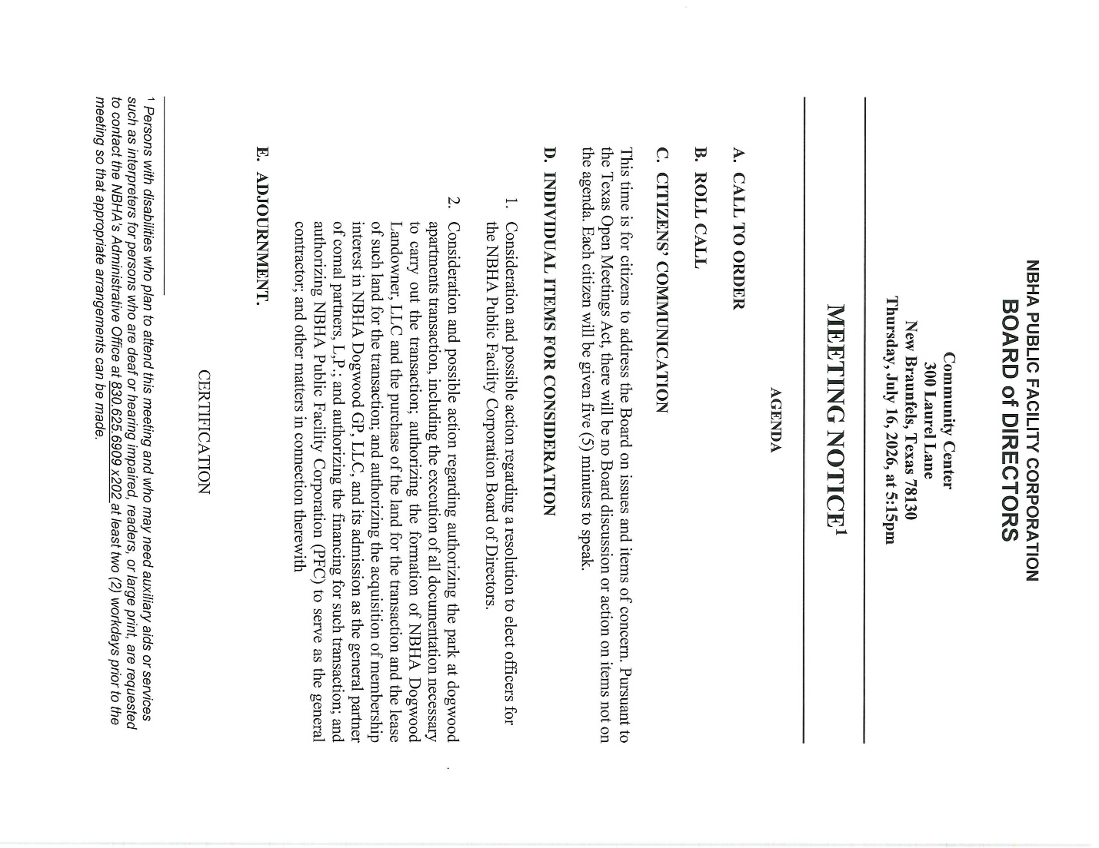

INDIVIDUAL ITEMS FOR CONSIDERATION D1
SUBJECT:
Consideration and Possible Action Regarding a Resolution to Elect Officers for the NBHA Public Facility Corporation Board of Directors.
BACKGROUND AND RATIONAL:
The election of officers is necessary to ensure the continued operation of the NBHA PFC and to provide authorized representatives who may execute documents, preside over meetings, and perform other duties required by the corporation's bylaws and applicable law. Electing officers promotes good governance and supports the corporation's ability to carry out future transactions and business activities. NBHA Public Facility Corporation (PFC) was created pursuant to Chapter 303 of the Texas Local Government Code to support the mission of the New Braunfels Housing Authority. Adoption of the PFC bylaws is necessary to formally establish governance structure, board authority, officer roles, meeting requirements, and operating procedures consistent with state law and NBHA oversight.
FISCAL IMPACT:
There is no direct fiscal impact associated with the election of officers.
STAFF RECCOMENDATION:
Staff recommends electing officers for the NBHA Public Facility Corporation Board of Directors as presented.

ATTACHMENT:
NBHA PUBLIC FACILITY BYLAWS
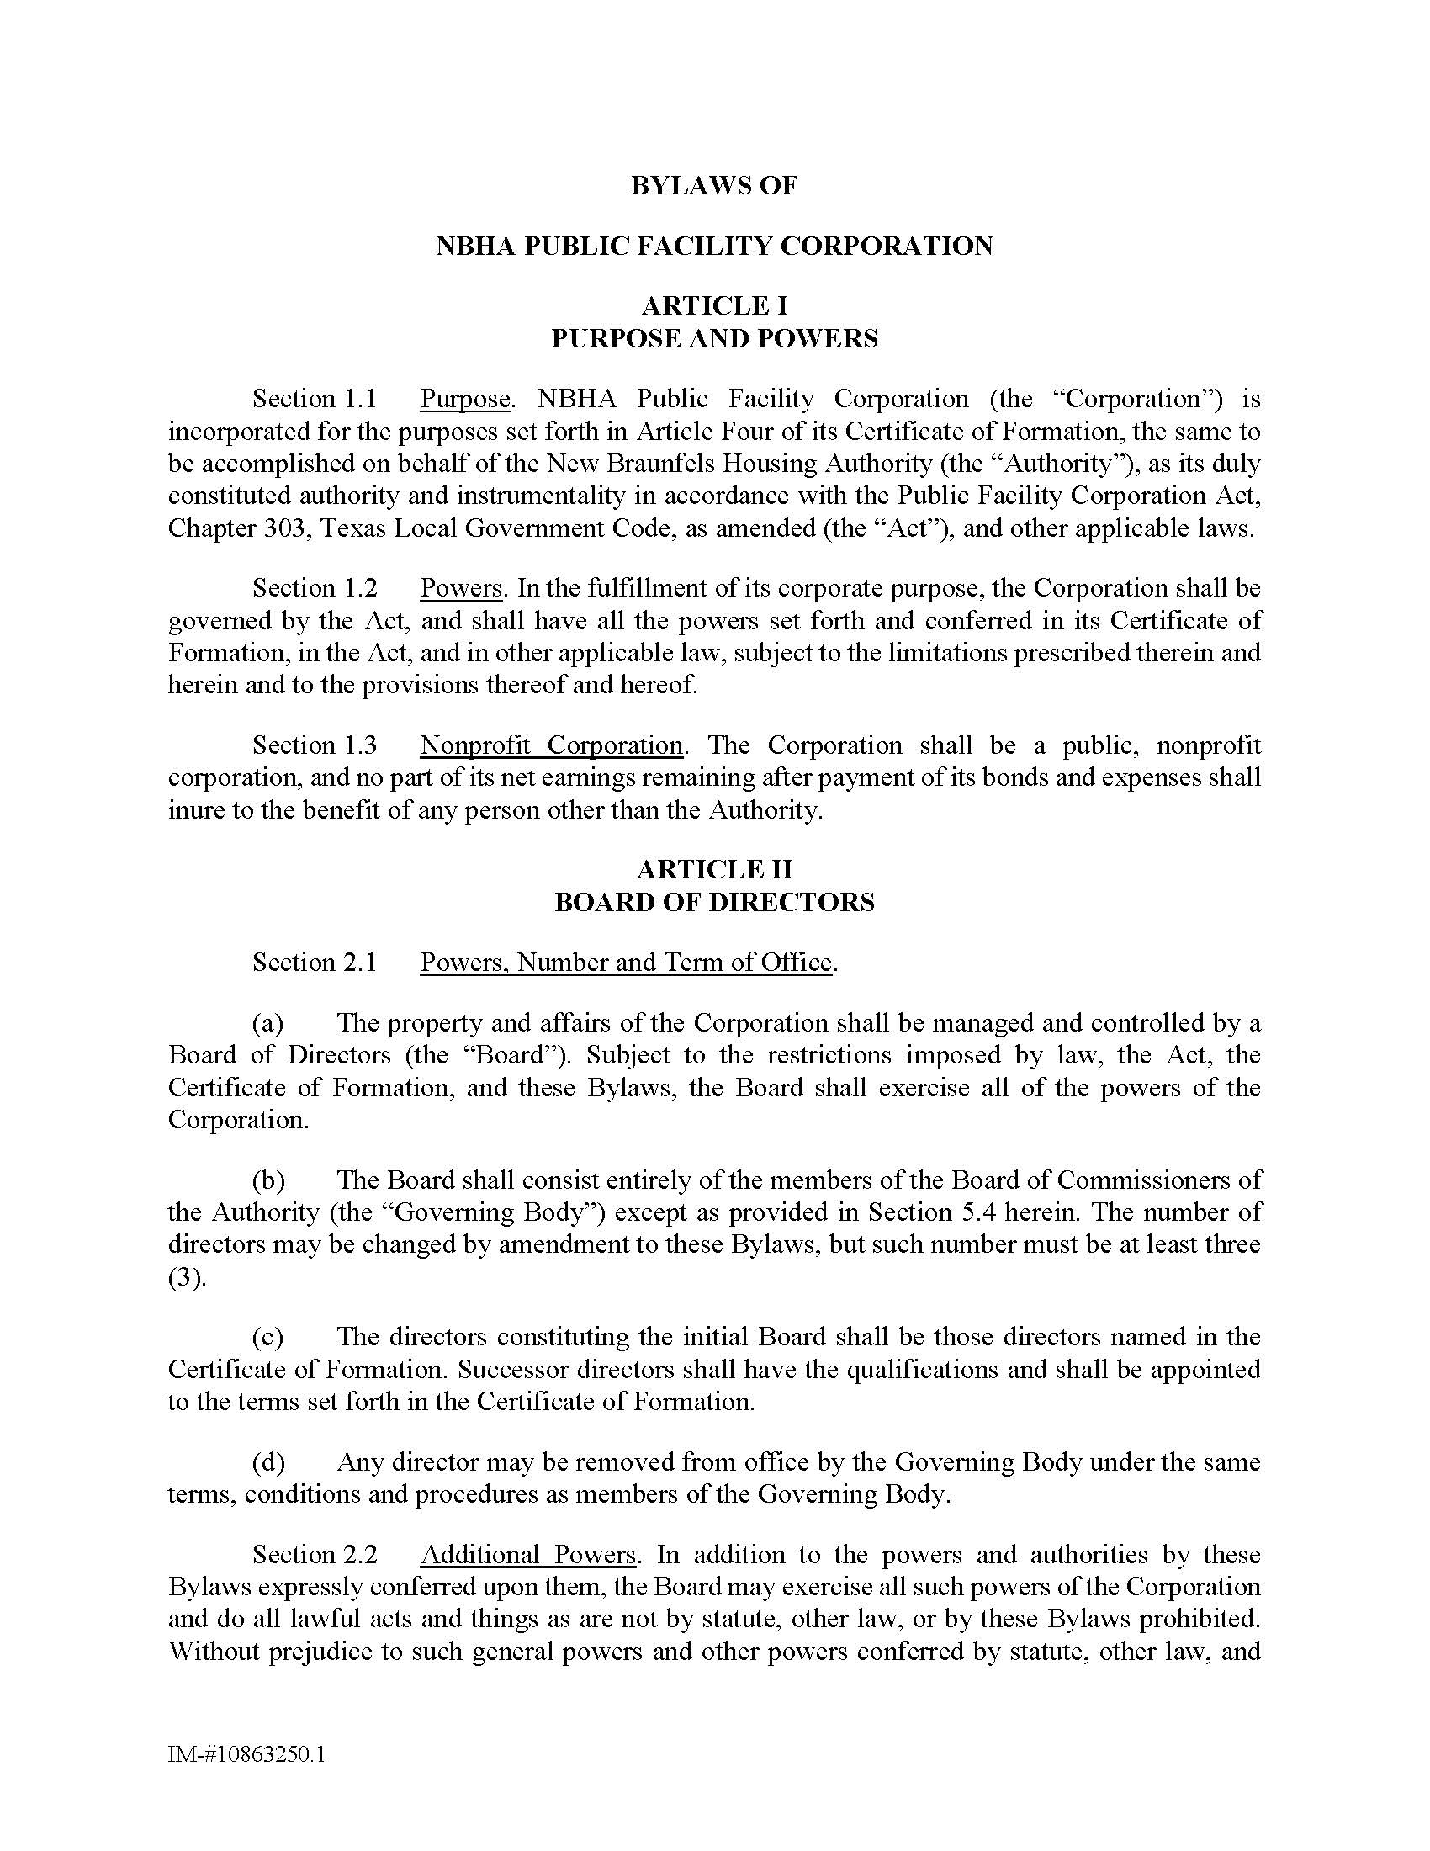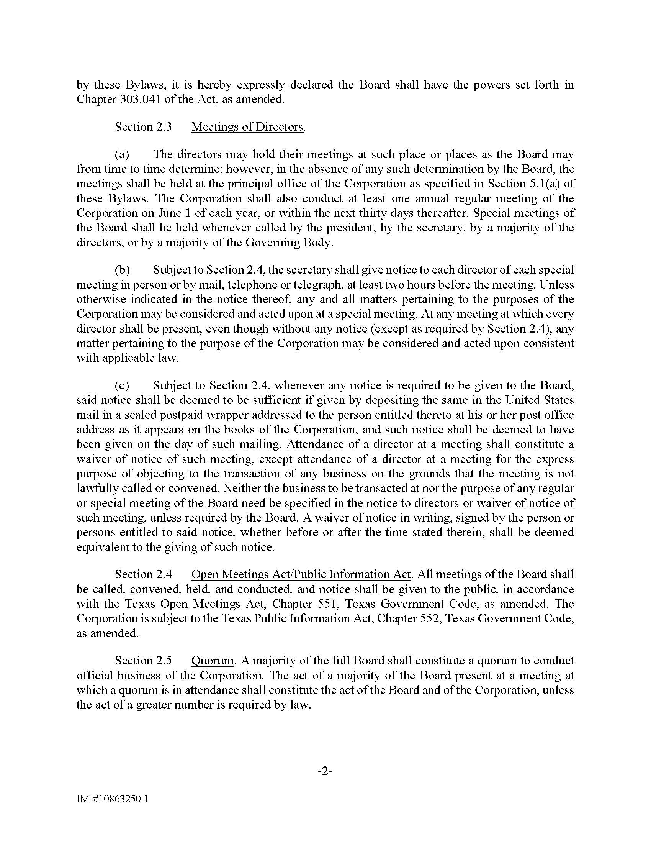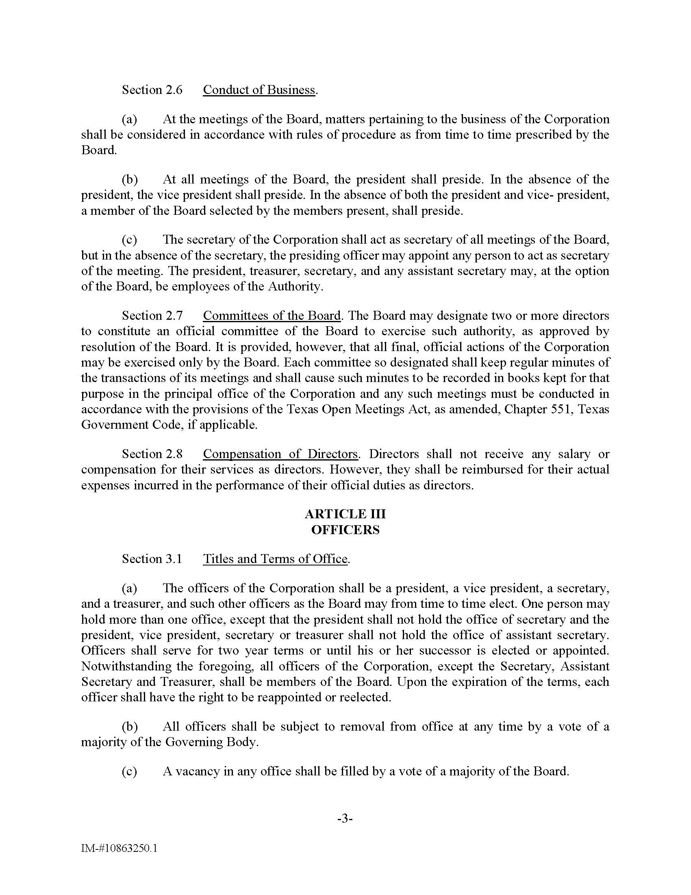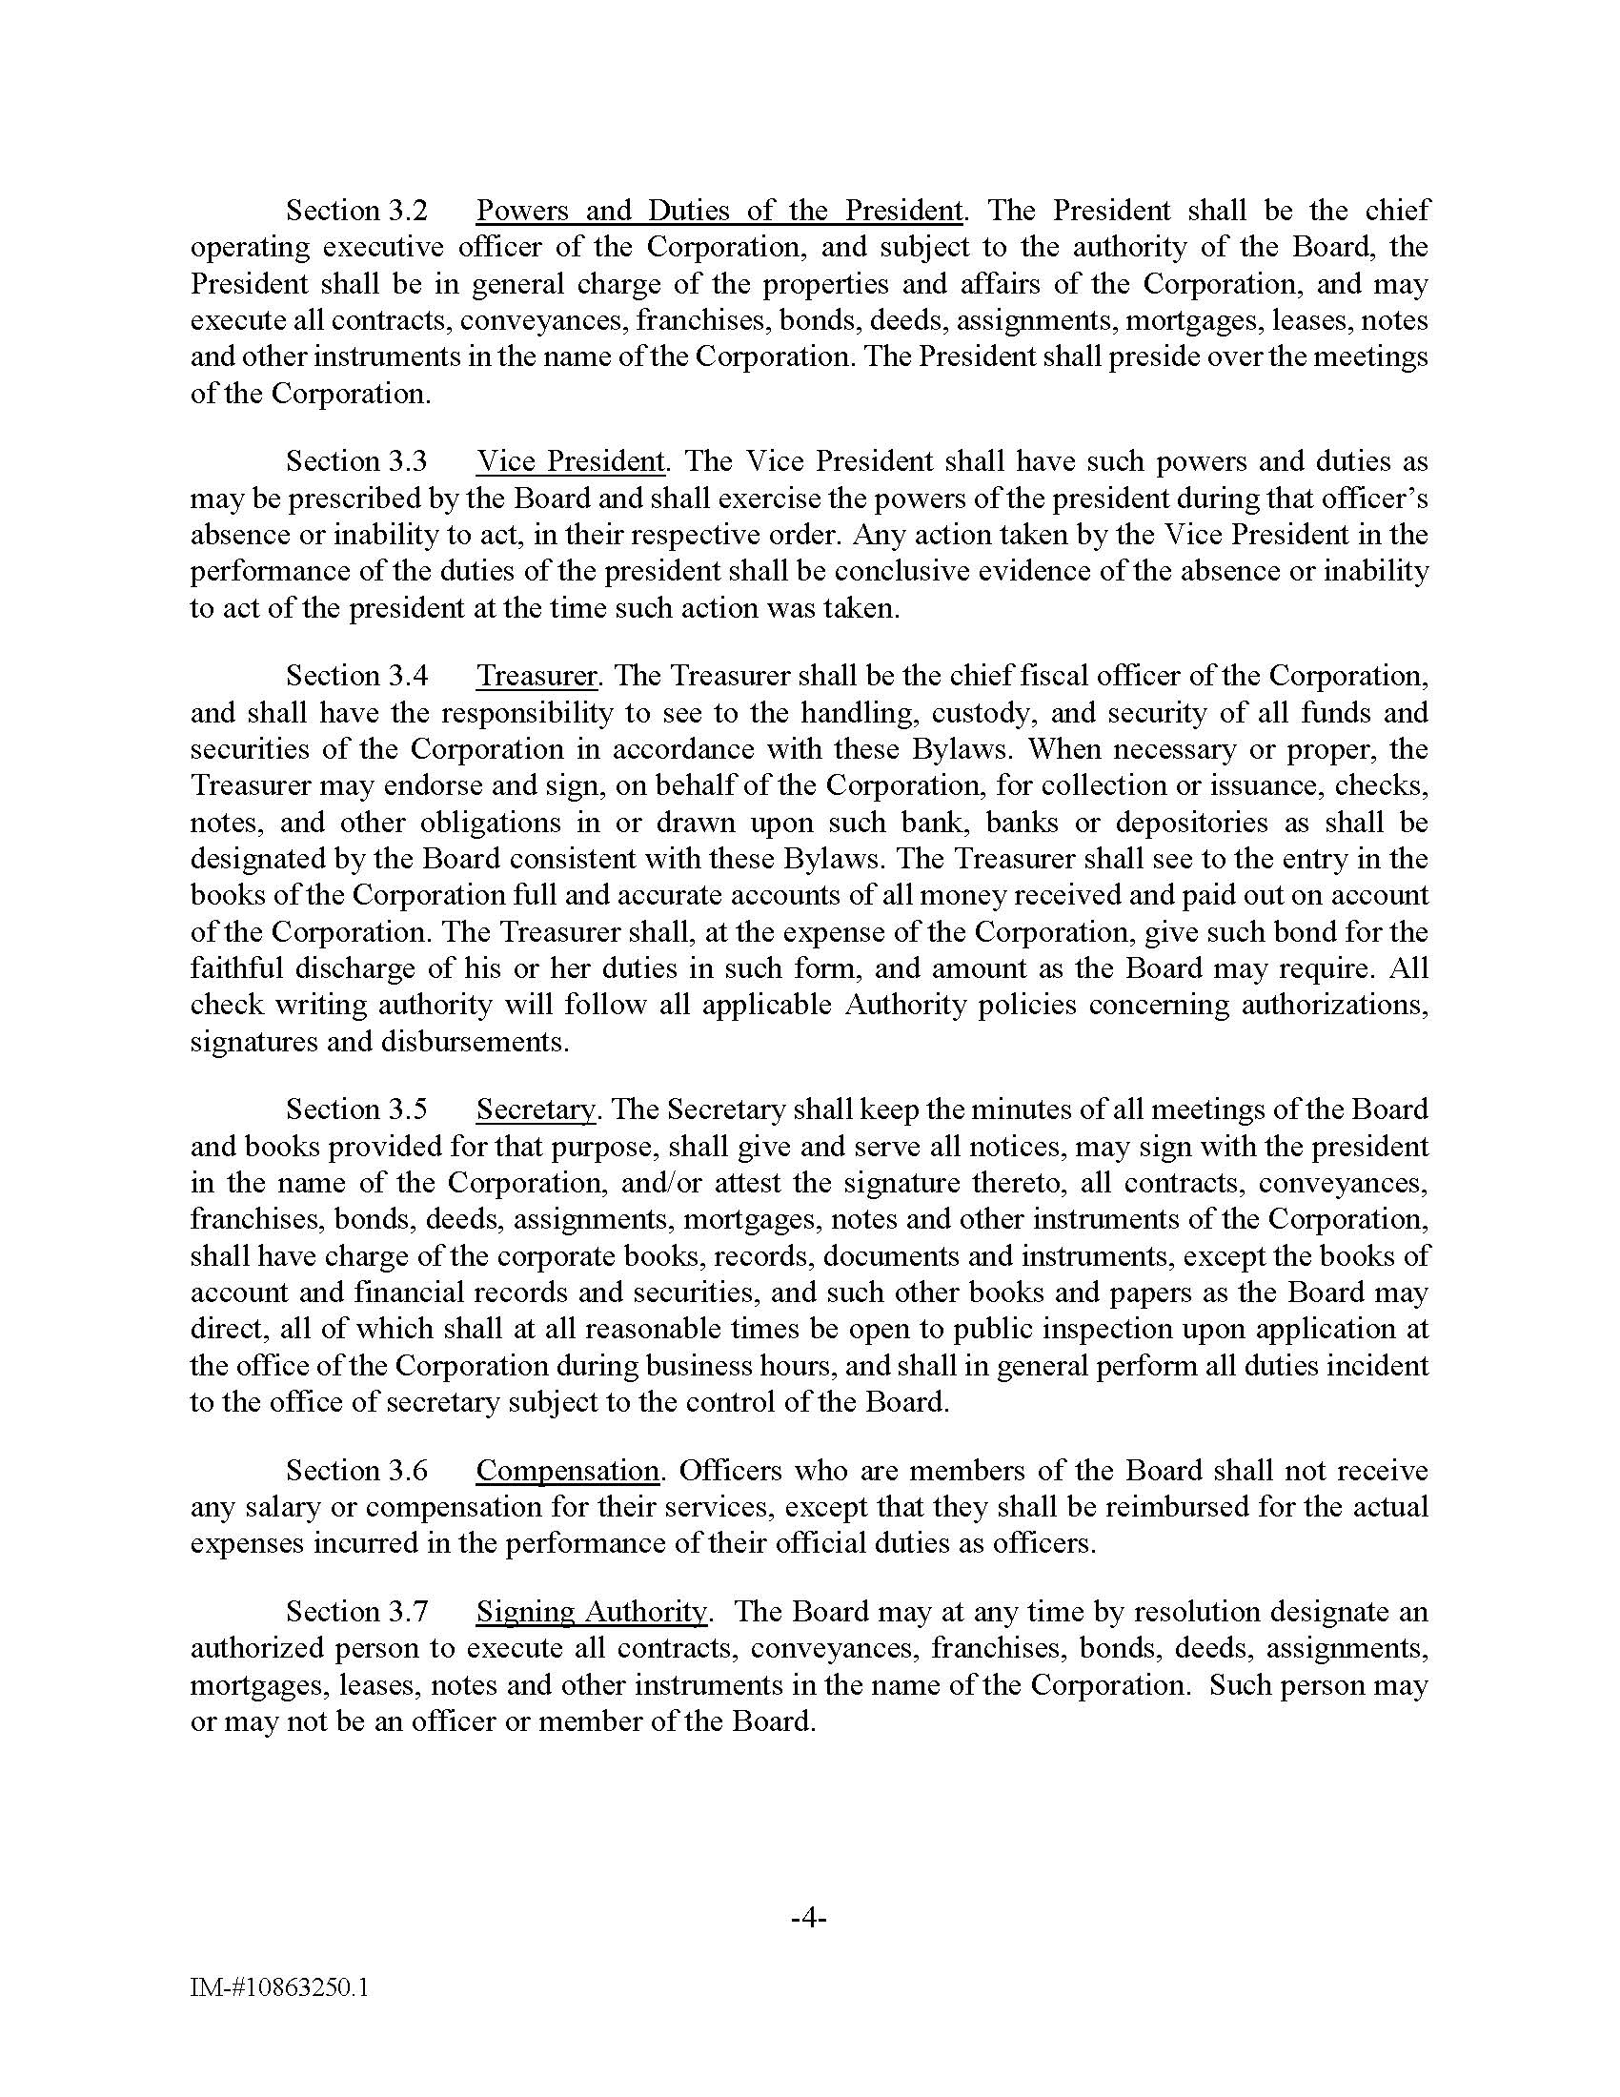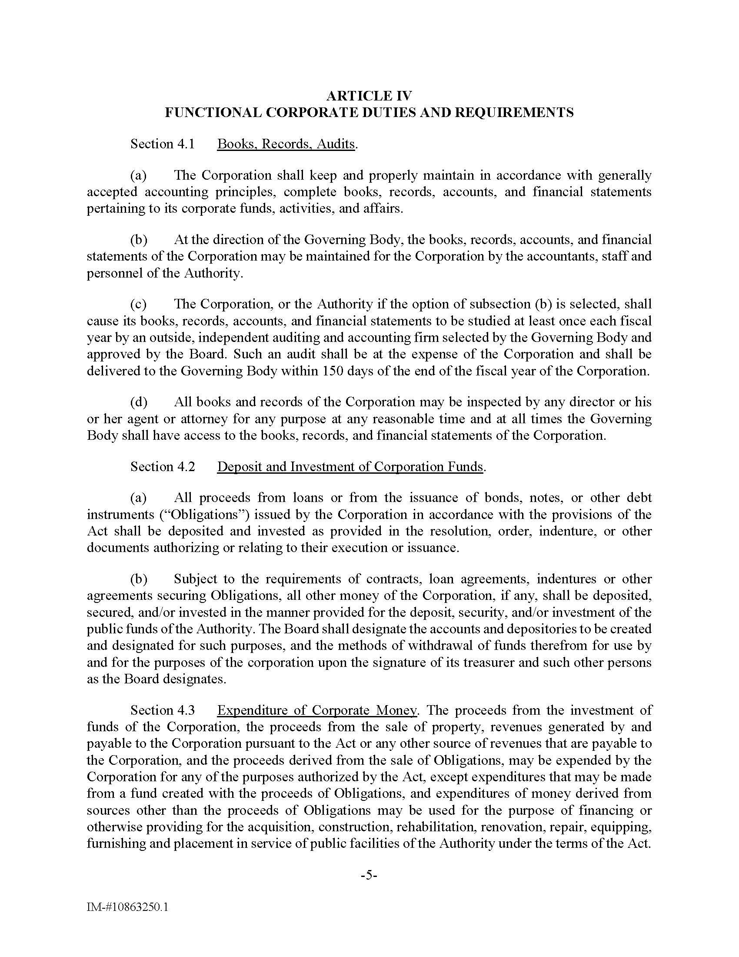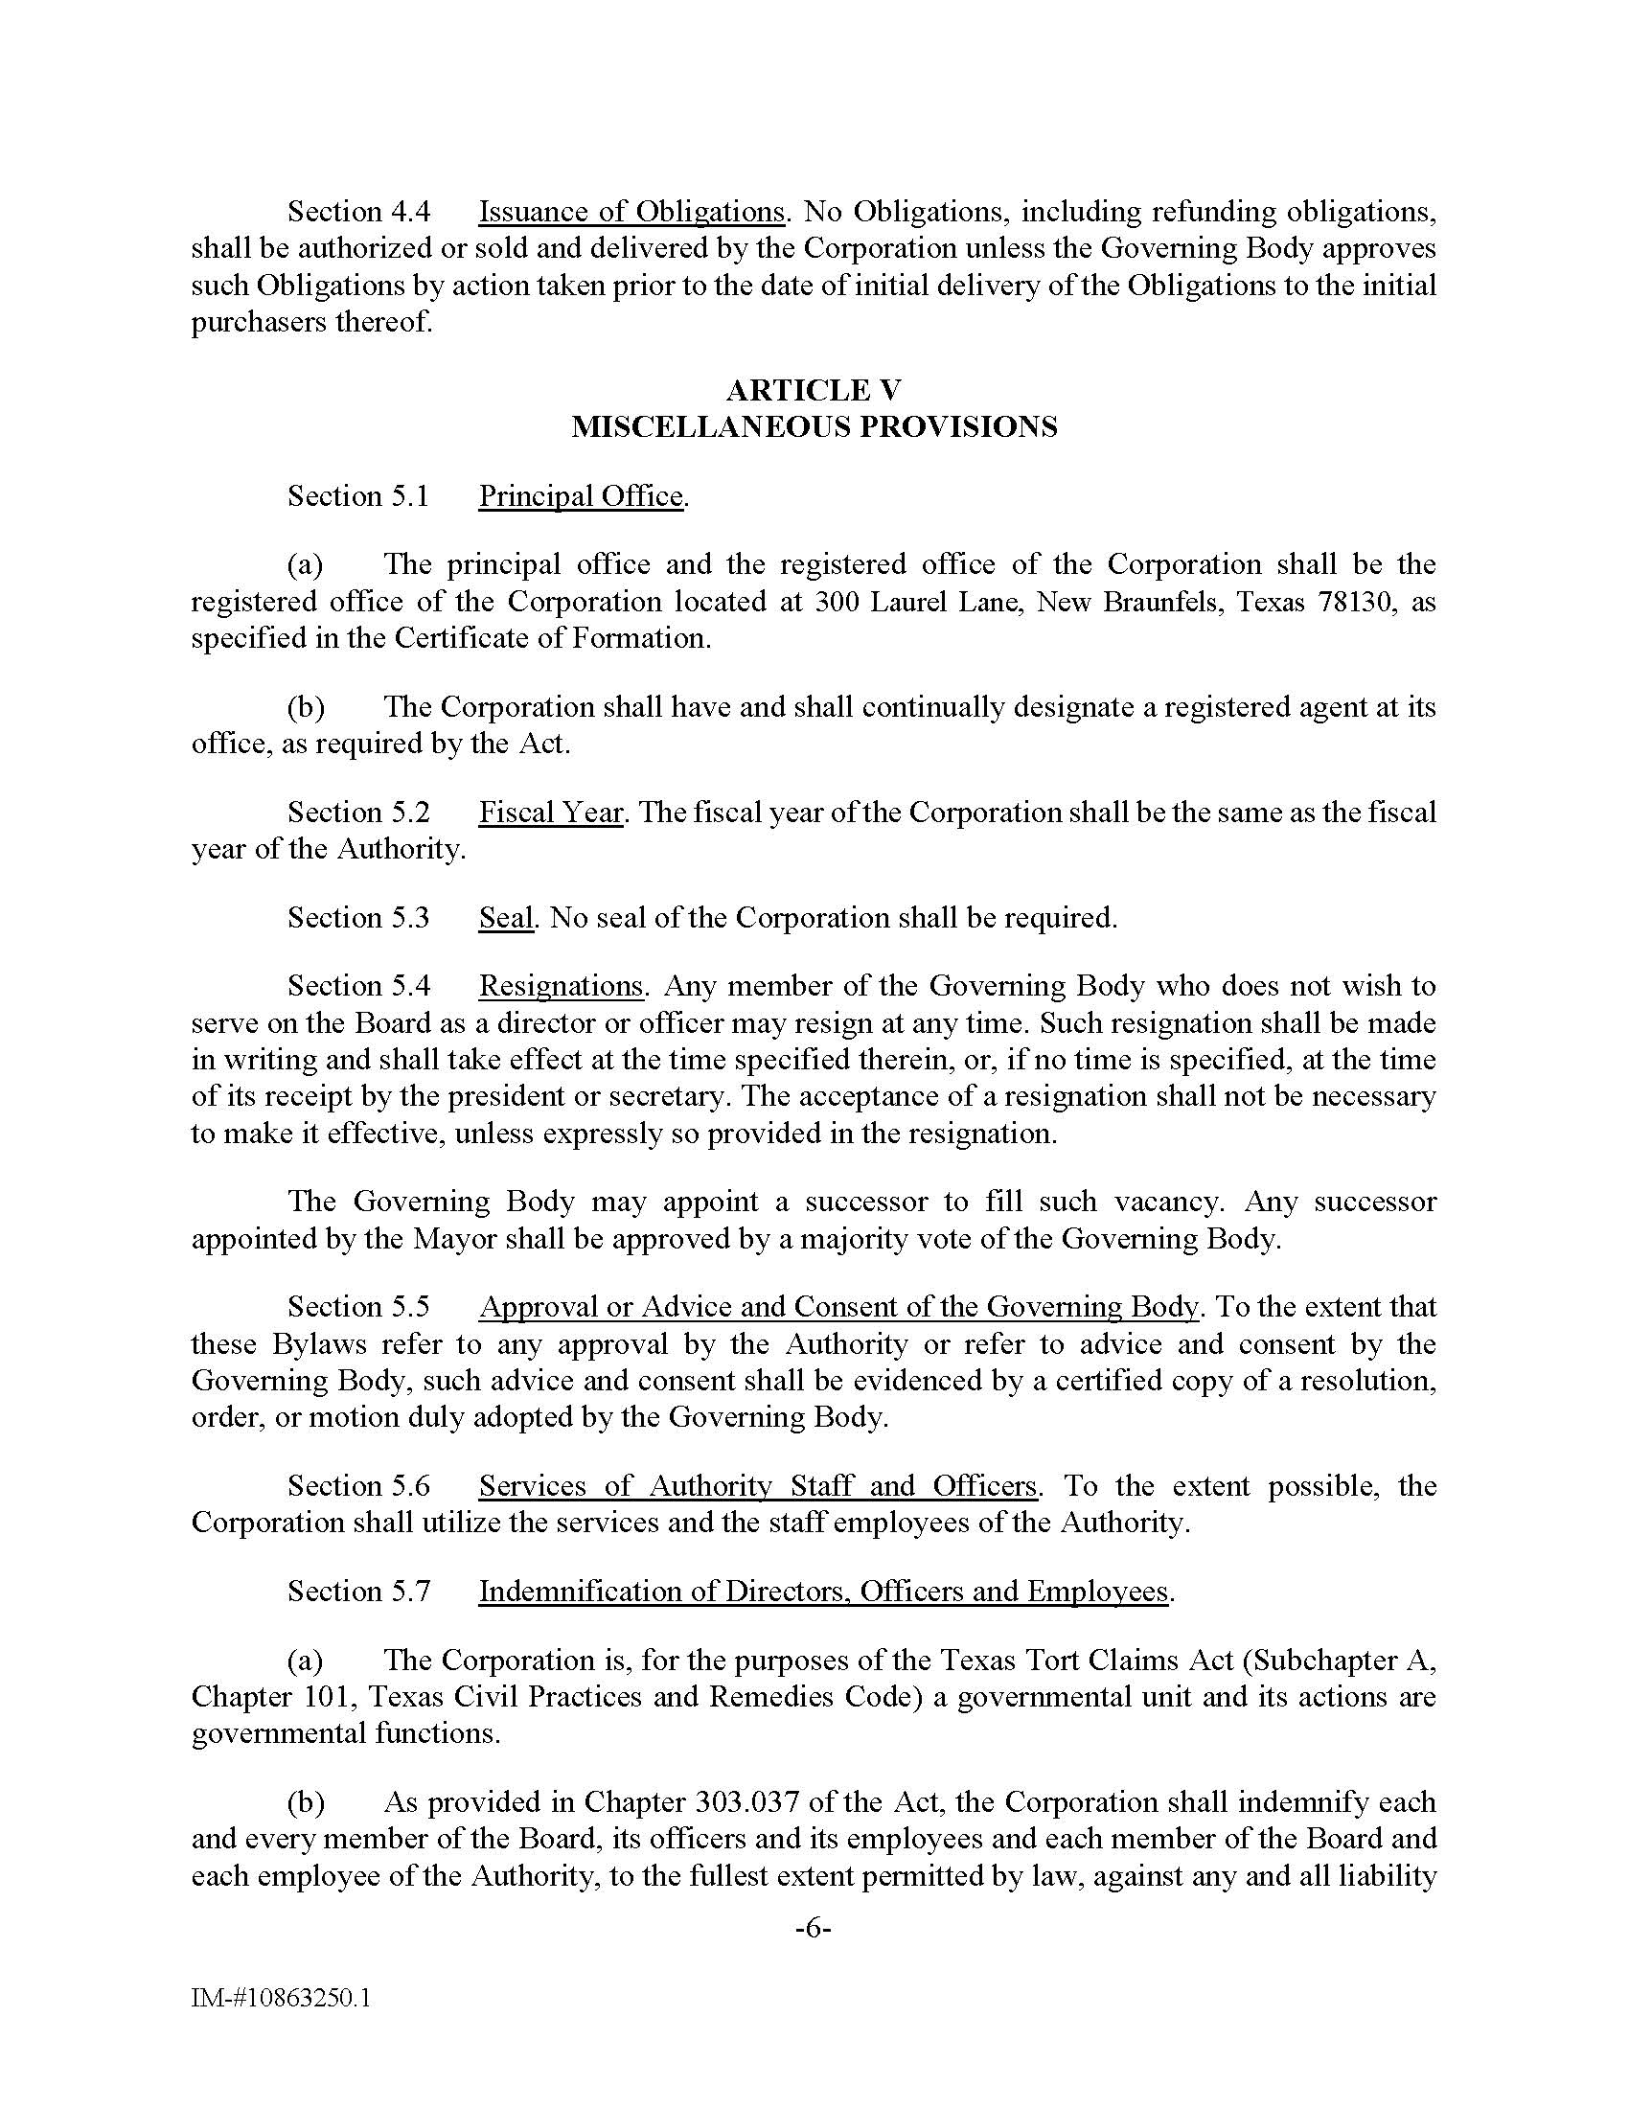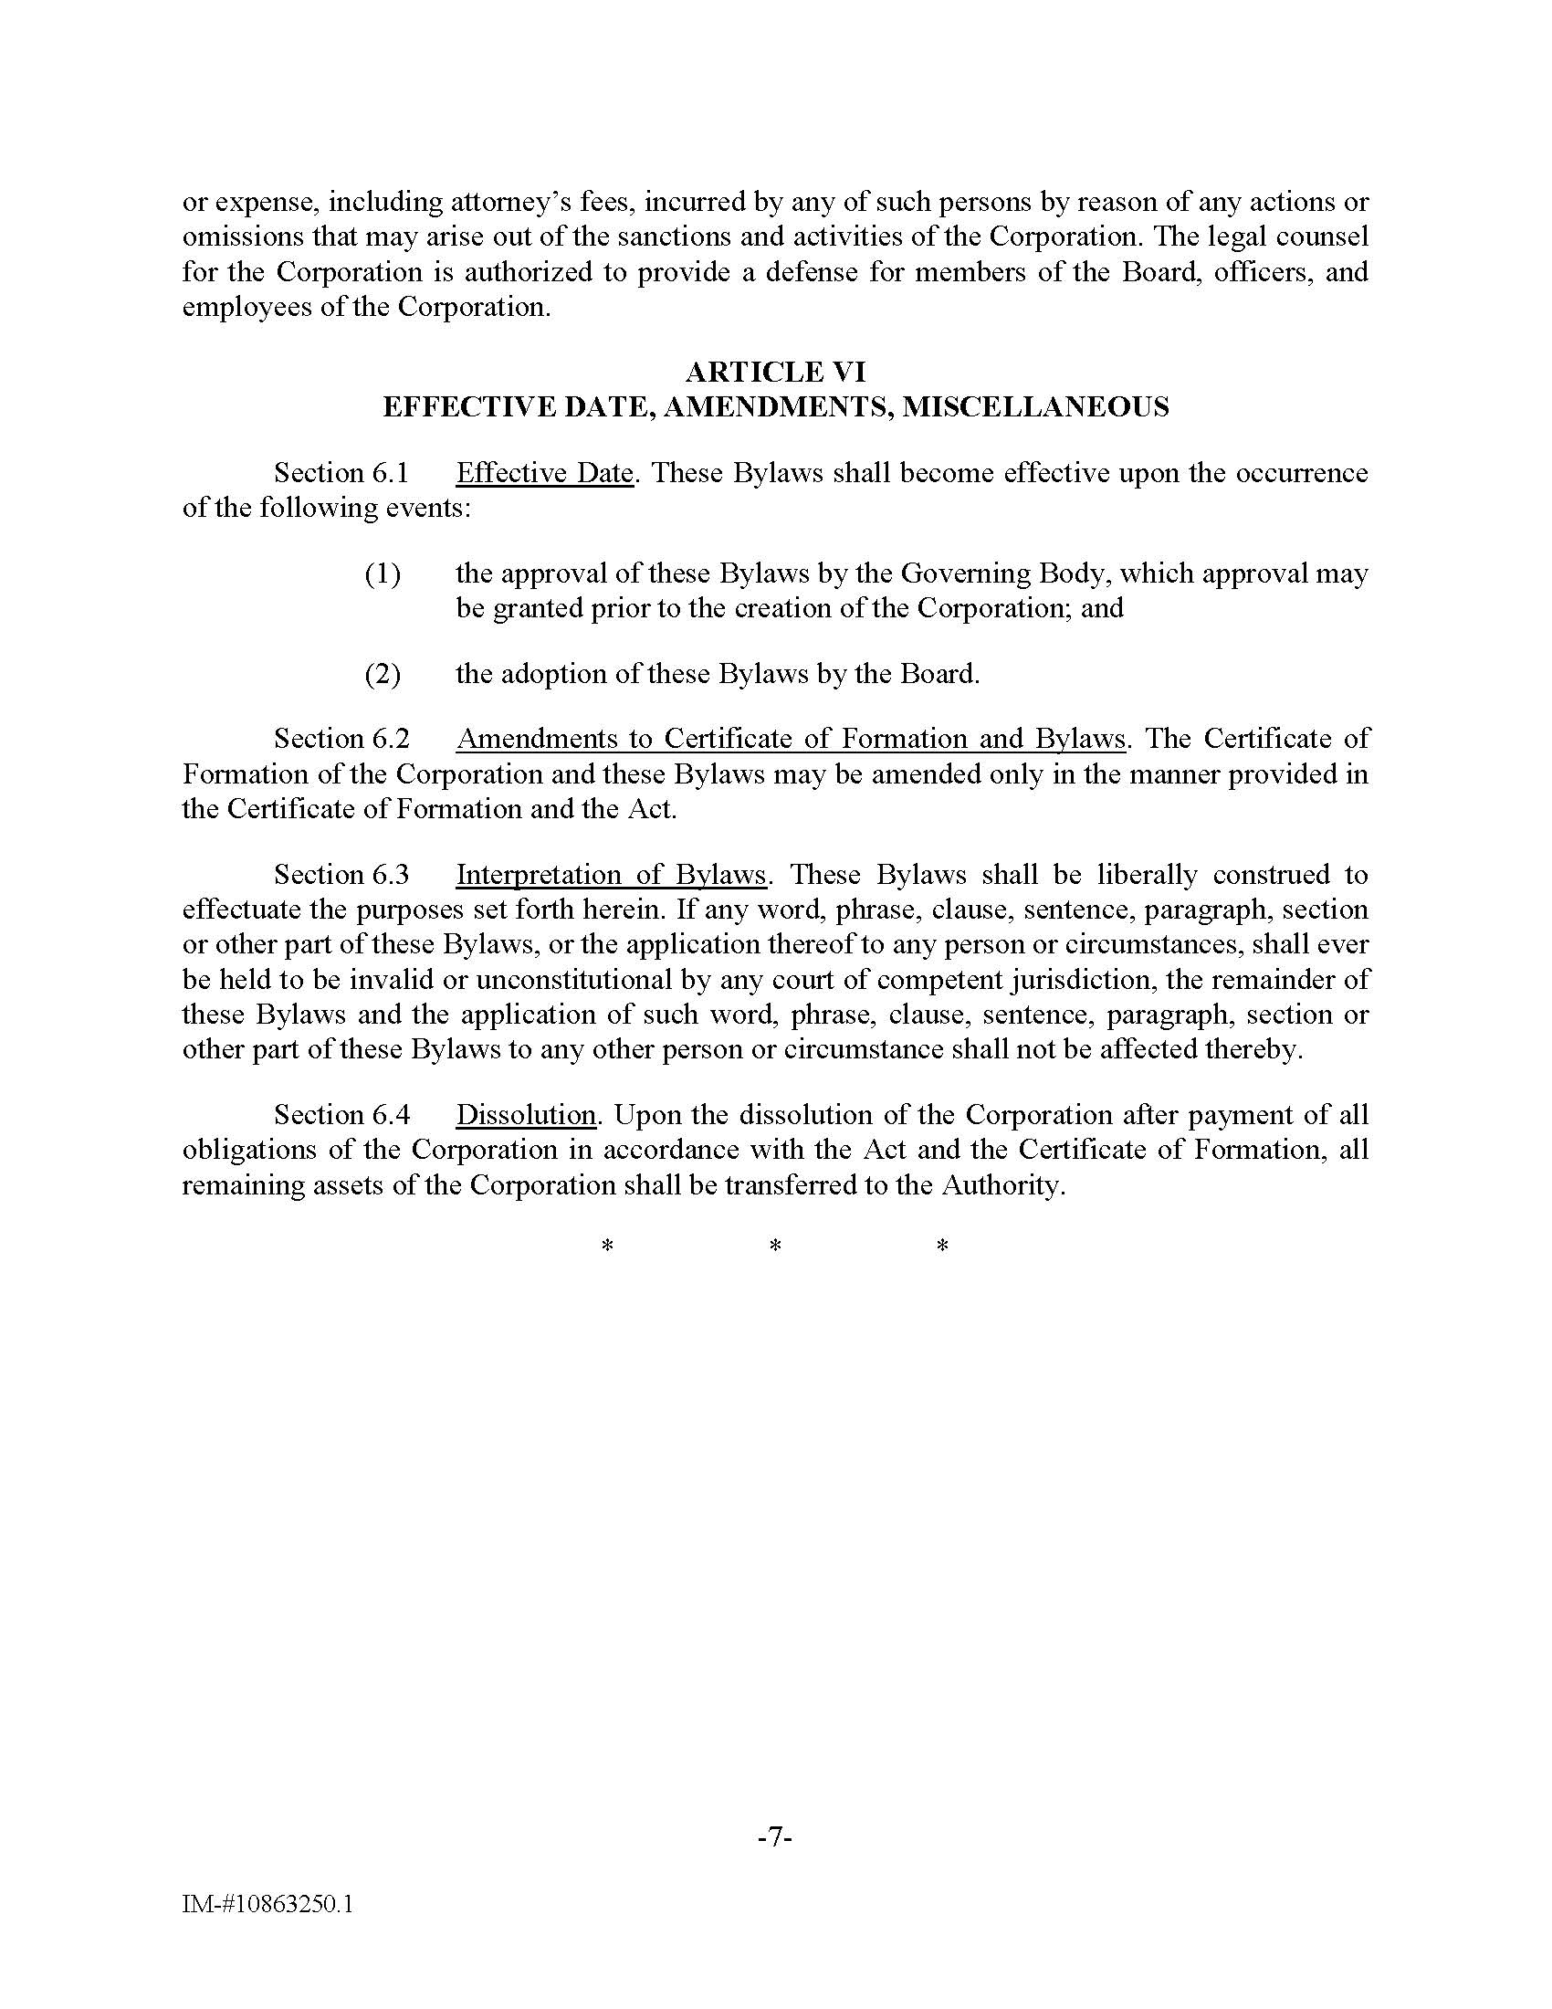
RESOLUTION NO. 202607160001
A RESOLUTION OF THE BOARD OF DIRECTORS OF THE NEW BRAUNFELS HOUSING AUTHORITY PUBLIC FACILITY CORPORATION ELECTING OFFICERS OF THE CORPORATION
WHEREAS, the New Braunfels Housing Authority Public Facility Corporation (the "Corporation") is a public facility corporation created pursuant to Chapter 303 of the Texas Local Government Code and the laws of the State of Texas; and
WHEREAS, the Corporation is governed by a Board of Directors and requires duly elected officers to conduct the business and affairs of the Corporation; and
WHEREAS, the Board of Directors finds that it is in the best interest of the Corporation to elect officers to serve in accordance with the Corporation's governing documents and applicable law.
NOW, THEREFORE, BE IT RESOLVED BY THE BOARD OF DIRECTORS OF THE NEW BRAUNFELS HOUSING AUTHORITY PUBLIC FACILITY CORPORATION THAT:
Section 1. Election of Officers
The following individuals are hereby elected to serve as officers of the Corporation until their successors are duly elected and qualified:
President: __________________________
Vice President: ______________________
Secretary: __________________________
Treasurer: __________________________
Section 2. Authority of Officers
The officers elected herein are authorized to perform all duties and responsibilities assigned to their respective offices under the Corporation's governing documents and applicable law.

Section 3. Effective Date
This Resolution shall take effect immediately upon its adoption.
PASSED AND APPROVED this ____ day of __________, 2026.

CERTIFICATE FOR RESOLUTION
The undersigned officer of the New Braunfels Housing Authority Public Facility Corporation, a public facility corporation created pursuant to the laws of the State of Texas (“NBHA PFC”), hereby certifies as follows:
- In accordance with its bylaws, the Board of Directors of NBHA PFC (the “Board”) held a meeting on July 16, 2026 (the “Meeting”), of the duly constituted officers and members of the Board, at which a duly constituted quorum was present. Whereupon, among other business transacted at the Meeting, a written
RESOLUTION 202607160001, APPROVING THE NEW BRAUNFELS HOUSING AUTHORITY PUBLIC FACILITY CORPORATION ELECTING OFFICERS OF THE CORPORATION
(the “Resolution”) was duly introduced for the consideration of the Board and discussed. It was then duly moved and seconded that the Resolution be adopted, and after due discussion, said motion, carrying with it the adoption of the Resolution, prevailed and carried by a majority vote of the Board.
- A true, full, and correct copy of the Resolution adopted at the Meeting is attached to and follows this Certificate. The Resolution has been duly recorded in the minutes of the Meeting; each of the officers and members of the Board was duly and sufficiently notified, officially and personally, in advance, of the time, place, and purpose of the Meeting; and the Meeting was held and conducted in accordance with the Bylaws of NBHA PFC.
SIGNED AND SEALED ,2026.

____________________________________
Henry Alvarez, Secretary/Executive Director

(SEAL)
INDIVIDUAL ITEMS FOR CONSIDERATION D2
SUBJECT:
Consideration and possible action regarding authorizing the park at dogwood apartments transaction, including the execution of all documentation necessary to carry out the transaction; authorizing the formation of nbha dogwood landowner, llc and the purchase of the land for the transaction and the lease of such land for the transaction; and authorizing the acquisition of membership interest in nbha dogwood gp, llc, and its admission as the general partner of comal partners, l.p.; and authorizing the financing for such transaction; and authorizing nbha public facility corporation to serve as the general contractor; and other matters in connection therewith
BACKGROUND AND RATIONAL:
The Park at Dogwood Apartments transaction requires the formation of project ownership entities, acquisition and ground lease of the project land, admission of NBHA Dogwood GP, LLC as the General Partner of Comal Partners, L.P., approval of project financing, and authorization for the NBHA Public Facility Corporation to serve as General Contractor. These actions are necessary to establish the ownership, financing, and development structure required for the construction and long-term operation of the affordable housing development.
FISCAL IMPACT:
There Project costs and financing obligations will be borne by the affiliated project entities and financing sources associated with the development. No direct financial obligation of NBHA is anticipated beyond its participation in the transaction approvals.
STAFF RECCOMENDATION:
Staff recommends approval of the Park at Dogwood Apartments transaction and authorization of all documents and actions necessary to complete the development, financing, ownership, and construction structure for the Project.

RESOLUTION NO. 202607160002

RESOLUTION 202607160002, AUTHORIZING THE PARK AT DOGWOOD APARTMENTS TRANSACTION, INCLUDING THE EXECUTION OF ALL DOCUMENTATION NECESSARY TO CARRY OUT THE TRANSACTION; AUTHORIZING THE FORMATION OF NBHA DOGWOOD LANDOWNER, LLC AND THE PURCHASE OF THE LAND FOR THE TRANSACTION AND THE LEASE OF SUCH LAND FOR THE TRANSACTION; AND AUTHORIZING THE ACQUISITION OF MEMBERSHIP INTEREST IN NBHA DOGWOOD GP, LLC, AND ITS ADMISSION AS THE GENERAL PARTNER OF COMAL PARTNERS, L.P.; AND AUTHORIZING THE FINANCING FOR SUCH TRANSACTION; AND AUTHORIZING NBHA PUBLIC FACILITY CORPORATION TO SERVE AS THE GENERAL CONTRACTOR; AND OTHER MATTERS IN CONNECTION THEREWITH
WHEREAS, the New Braunfels Housing Authority (the “Authority”), has, pursuant to the Texas Public Facility Corporations Act, Chapter 303, Texas Local Government Code, as amended (the “Act”), approved and created the NBHA Public Facility Corporation, a nonstock, nonprofit public facility corporation (“NBHAPFC”); and
WHEREAS, NBHAPFC, on behalf of the Authority, is empowered to finance the costs of public facilities that will provide decent, safe, and sanitary housing for persons of low income in the City of New Braunfels; and
WHEREAS, Comal Partners, L.P., a Mississippi limited partnership authorized to transact business in Texas under the name of Comal Partners TX, L.P. (the “Partnership”), and NBHA Dogwood GP, LLC, a Texas limited liability company and its sole general partner (the “General Partner”), have been formed to acquire and construct an approximately 76-unit low-income housing tax credit facility (the “Housing Facility”) located at approximately 1869 McQueeney Rd., New Braunfels, Texas 78130 and to be known as Park at Dogwood Apartments (the “Project”); and
WHEREAS, at the request of the Partnership, NBHAPFC has agreed to (i) serve as the sole member of the General Partner in connection with the financing of the Project (with an affiliate of the Developer (as hereinafter defined) acting as a special limited partner in the Partnership), (ii) serve as a co-developer of the Project, (iii) acquire the Land and lease it to the Partnership pursuant to a Ground Lease (the “Ground Lease”), and (iv) serve as the general contractor for the Project;
WHEREAS, in connection with the financing of the Project, the Partnership will enter into a loan transaction with JPMorgan Chase Bank, N.A. for a construction loan (the “Construction Loan”) in the approximate amount of $13,800,000;
WHEREAS, in connection with the execution of the Construction Loan, the Partnership, the General Partner and/or NBHA will be required to enter into certain agreements, including, but not limited to, a Construction Loan Agreement, a Promissory Note, a Construction Leasehold Deed of Trust, Security Agreement, Assignment of Leases and Rents and Fixture Filing, a Joinder of Ground Lessor to Construction Leasehold Deed of Trust, Security Agreement, Assignment of Leases and Rents and Fixture Filing, an Assignment of Permits and Contracts, an Assignment of Property Management Agreement, an Environmental Indemnity Agreement, a Pledge and Assignment Agreement, a Collateral Assignment and Pledge of Developer Fees and Security Agreement, an Assignment and Security Agreement (Investor Obligations & Tax Credits), a Collateral Assignment and Pledge of Partnership Interest, Recognition, Attornment and Assent to Leasehold Security Instrument (Senior Mortgage), Subordination Agreement together with various assignments and certificates or other similarly named documents, as the same may be amended, restated, renewed, extended and modified (collectively, the “Construction Loan Documents”);
WHEREAS, in connection with the financing of the Project, the Partnership will also enter into a loan transaction with Security Bank and Trust Company, a Tennessee state banking corporation (the “Permanent Lender”), for a loan in the aggregate amount of approximately $4,700,000 (the “Permanent Loan”);
WHEREAS, in connection with the execution of the Permanent Loan, the Partnership, the General Partner and/or NBHA will be required to enter into certain agreements, including, but not limited to, a Loan Agreement, a Promissory Note, a Leasehold Deed of Trust, Assignment of Rents, Security Agreement and Fixture Filing, an Assignment of Leases and Rents, an Assignment of Licenses, Permits and Contracts, a Subordination and Collateral Assignment of Management Agreement and an Environmental Indemnity Agreement, together with various assignments and certificates or other similarly named documents (collectively, the “Permanent Loan Documents”);
WHEREAS, Park Development Group, LLC or its affiliate (the “Developer”), on behalf of the Partnership, has applied for low-income housing tax credits (the “LIHTCs”) from the Texas Department of Housing and Community Affairs (“TDHCA”);
WHEREAS, in connection with the application for LIHTCs, it is anticipated that the Partnership, General Partner and/or NBHAPFC will be required to execute, complete and deliver various applications, agreements, documents, certificates and instruments to TDHCA (the “TDHCA Documents”);
WHEREAS, the Partnership will contribute approximately $15,698,430 of equity to the construction of the Project, which will be raised from the sale of the LIHTCs, which is anticipated to be made to PNC Bank, National Association or an affiliate thereof (the “Equity Financing”);
WHEREAS, in connection with the Equity Financing, the Partnership, the General Partner, and/or NBHAPFC will be required to enter into certain agreements, including but not limited to an Amended and Restated Agreement of Limited Partnership, or any such similarly named document, and any documents attached as exhibits thereto, a Development Agreement and closing certificates (collectively, the “Equity Documents”);
WHEREAS, to reduce the cost of the Project by eliminating sales tax on the construction materials for the Project, NBHAPFC will serve as the general contractor for the Project (the “General Contractor”) and enter into any required construction contracts, subcontracts and ancillary documents, and various other similarly named documents (the “Construction Documents”);
WHEREAS, the Board has determined that it is in the public interest and to the benefit of the citizens and residents of New Braunfels for the various entities to enter into the transactions described above so that the Partnership may construct the Project; and
WHEREAS, this Board has reviewed the foregoing and determined that the action herein authorized is in furtherance of the public purposes of NBHAPFC.
NOW, THEREFORE, BE IT RESOLVED by the Board of Directors of the NBHA Public Facility Corporation, that:
  - The Project, the various forms of financing contemplated for the Project, including but not limited to the Construction Loan, the Permanent Loan, the LIHTCs, and the Equity Financing and the terms of the Construction Loan Documents, the Permanent Loan Documents, the TDHCA Documents, the Equity Documents, and the Construction Documents are hereby authorized and approved when such documents are executed by the officers provided below.
  - The President, any Vice President, the Secretary/Treasurer, any Assistant Secretary/Treasurer, any other officer, or Henry Alvarez, as Authorized Signatory or any of them, are hereby authorized to execute any and all documentation required for the financing and construction of the Project, including, but not limited to, the Construction Loan Documents, the Permanent Loan Documents, the TDHCA Documents, the Equity Documents and the Construction Documents, indemnity agreements and guaranties covering the Land or the Project, and all other documents relating to the Construction Loan, the Permanent Loan, the LIHTCs, the Equity Financing and the Construction Documents to which the Partnership, the General Partner, and/or NBHAPFC is a party.
  - The purchase of the Land, the Ground Lease, the acquisition of membership interest in the General Partner by NBHAPFC and General Partner’s admission as the sole general partner of the Partnership, and the role of NBHAPFC as a co-developer of the Project and the General Contractor are each approved and the President, any Vice President, the Secretary/Treasurer, and any Assistant Secretary/Treasurer, any other officer, or Henry Alvarez, as Authorized Signatory or any of them, are hereby authorized to execute the documents required to be executed by NBHAPFC in order to effect such transactions.
  - The President, any Vice President, the Secretary/Treasurer, and the Assistant Secretary/Treasurer, any other officer, or Henry Alvarez, as Authorized Signatory, or any of them, and, if required by the form of the document, the Secretary/Treasurer and any Assistant Secretary/Treasurer, any other officer, or Henry Alvarez, as Authorized Signatory, or any of them, of NBHAPFC are authorized and directed to modify, execute and deliver any of the documents to be signed by or consented to by NBHAPFC, and any and all certificates and other instruments necessary to carry out the intent thereof and hereof. The President, any Vice President, the Secretary/ Treasurer, any Assistant Secretary/Treasurer, any other officer or Henry Alvarez, as Authorized Signatory, or any of them, are authorized to negotiate and approve such changes in, or additions to, the terms of any of the documents, including amendments, renewals, and extensions, as such officers shall deem necessary or appropriate upon the advice of counsel to NBHAPFC, and approval of the terms of any of the documents by such officers and this Board shall be conclusively evidenced by the execution and delivery of such documents.
  - The members and officers of this Board, or any of them, or Henry Alvarez, as Authorized Signatory, are authorized to take any and all action necessary to carry out and consummate the transactions described in or contemplated by the documents approved hereby or otherwise to give effect to the actions authorized hereby and the intent hereof.
  - If any section, paragraph, clause, or provision of this Resolution shall be held to be invalid or unenforceable, the invalidity or unenforceability of such section, paragraph, clause, or provision shall not affect any of the remaining provisions of this Resolution.
  - The recitals contained in the preamble hereof are hereby found to be true, and such recitals are hereby made a part of this Resolution for all purposes and are adopted as a part of the judgment and findings of the Board.
  - All resolutions hereby made a part of this Resolution for all purposes and are adopted as a part of the judgment and findings of the Board, or parts thereof, which are in conflict or inconsistent with any provision of this Resolution are hereby repealed to the extent of such conflict, and the provisions of this Resolution shall be and remain controlling as to the matters resolved herein.
  - Any an all action taken by the Authorized Signatory or any other authorized officer of NBHAPFC, each acting on behalf of NBHAPFC, acting on its own behalf or on behalf of the General Partner, acting on its own behalf or as the general partner of the Partnership, prior to the date of this Resolution is actually executed in effecting the purposes of the foregoing is hereby approved, ratified, and adopted in all respects.
  - This Resolution shall be construed and enforced in accordance with the laws of the State of Texas and the United States of America.
  - This Resolution shall be in force and effect from and after its passage.

CERTIFICATE FOR RESOLUTION

The undersigned officer of the NBHA Public Facility Corporation, a Texas nonprofit corporation created pursuant to the laws of the State of Texas (“NBHAPFC”) hereby certifies as follows:
- In accordance with the bylaws of NBHAPFC, the Board of Directors of NBHAPFC (the “Board”) held a meeting on July 16, 2026 (the “Meeting”) of the duly constituted officers and members of the Board, at which a duly constituted quorum was present. Whereupon among other business transacted at the Meeting, a written

RESOLUTION 202607160002, AUTHORIZING THE PARK AT DOGWOOD APARTMENTS TRANSACTION, INCLUDING THE EXECUTION OF ALL DOCUMENTATION NECESSARY TO CARRY OUT THE TRANSACTION; AUTHORIZING THE FORMATION OF NBHA DOGWOOD LANDOWNER, LLC AND THE PURCHASE OF THE LAND FOR THE TRANSACTION AND THE LEASE OF SUCH LAND FOR THE TRANSACTION; AND AUTHORIZING THE ACQUISITION OF MEMBERSHIP INTEREST IN NBHA DOGWOOD GP, LLC, AND ITS ADMISSION AS THE GENERAL PARTNER OF COMAL PARTNERS, L.P.; AND AUTHORIZING THE FINANCING FOR SUCH TRANSACTION; AND AUTHORIZING NBHA PUBLIC FACILITY CORPORATION TO SERVE AS THE GENERAL CONTRACTOR; AND OTHER MATTERS IN CONNECTION THEREWITH
(the “Resolution”) was duly introduced for the consideration of the Board and discussed. It was then duly moved and seconded that the Resolution be adopted; and, after due discussion, said motion, carrying with it the adoption of the Resolution, prevailed and carried by a majority vote of the Board.

- A true, full, and correct copy of the Resolution adopted at the Meeting is attached to and follows this Certificate; the Resolution has been duly recorded in the Board’s minutes of the Meeting; each of the officers and members of the Board was duly and sufficiently notified officially and personally, in advance, of the time, place, and purpose of the Meeting; and the Meeting was held and conducted in accordance with the Articles of Incorporation and the Bylaws of NBHAPFC.

SIGNED and SEALED this 16th day of July 2026.

Henry Alvarez
Secretary/Treasurer
(SEAL)

- ADJOURNMENT.

